**DATA COMMUNICATION COMPONENETS**

**Introduction**

* **Data** is sometimes also called as **input**.
* **Information:** Processed form of **data**.
* **Data communication:** Exchange of data b/w two devices via **transmission medium**.

**Data Communication Components**

* **Sender**
* **Receiver**
* **Medium**
  + Wired examples: **Twisted pair wire, coaxial cable, fiber-optic cable etc.**
  + Unwired examples: **Laser waves, radio waves etc.**
* **Message**
* **Protocol:** Set of rules during data communication.
  + Two devices must have **same protocols** in order to communicate.
  + Otherwise, they **can** connect but **can’t** interact.

**Data Flow**

* **Simplex:** **Mainframe** (transmitter) to **station** (receiver) unidirectional communication.
* **Half-duplex:** **Station to station** bidirectional communication, but if one is transmitting then at that time the other one can only receive.
* **Full-duplex:** Station to station bidirectional communication & **both can receive or transmit** at the same time.

**Computer Network**

* **Network:** A system of computers connected to each other.
* **System:** A real or virtually **isolated** space.
* It is done primarily for sharing of information.
* Internet is one kind of network.

Advantages:-

* Internet access
* Entertainment
* **Flexible access:** Accessing files through any computer in common network.
* Concurrent accesses

**Topology**

* **Topology:** Geometric representation of how the computers are connected to each other.
* Types of topologies: **Bus, mesh, star, ring, hybrid etc.**

**Bus Topology**

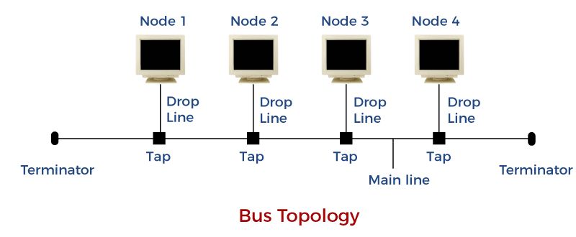

* **Backbone cable:** See the horizontal line in figure.
* **Tap:** A three way connecting device linking drop lines to main cable.
* There is **limit** to length of both **drop line & main cable**.

Advantages:-

* Simple installation
* Less cable requirement

Disadvantages:-

* Difficulty detecting faults.
* Not scalable due to limit.

**Star Topology**

* **Central device:** Device to which **all** other devices are connected.
* No direct communication among devices.
* Here, central device is a **hub**.

Advantages:-

* Less costly
* Easy installation
* Less cables required
* If one connection fails then others will remain **unaffected**.
* Easy detecting faults

Disadvantages:-

* If hub fails, then **whole** system goes down.
* Hub consumes a lot of energy.
* Hub also requires frequent maintenance.

**Ring Topology**

* Each device has **two** point-to-point connections.
* In ring topology, we use a **repeater**.
* **Repeater:** A device which forwards the data to next adjacent device if it is not meant for it.

Advantages:-

* Easy installation
* Scalability

Disadvantages:-

* If one device fails then data **won’t** move forward.
* Data trafficking (being circular)

**Mesh Topology**

* **Many-to-many** style connection.
* **Committed connection:** Mesh b/w two devices.
* **No. of mesh connections = n(n-1)/2**

Advantages:-

* No network trafficking
* Stable/durable
* Safe
* Easy fault detection

Disadvantages:-

* Complex
* Massive number of **I/O ports**
* Expensive scalability

**Hybrid Topology**

* Combination of multiple topologies.

Advantages:-

* Covers shortcomings
* Scalability

Disadvantages:-

* Difficulty detecting faults
* Difficult setup
* Expansive

**Protocol**

* Required for **secured** communication.
* **FTP** is used for file sharing.
* **SMTP** is used by email.
* **Telnet** is used for **virtual terminals**.
* **Virtual terminal:** Web-based app allowing online money transaction.

**OSI Model**

* **Open Source Interconnection** model.
* Contains 7 layers.
* Defines how data is transferred from one computer to another.
* Data is passed using **NIC**.
* **NIC:** Network interface card.
* Was introduced (**1984**) by **ISO**.
* **ISO:** International Organisation for Standardisation.

7 layers:-

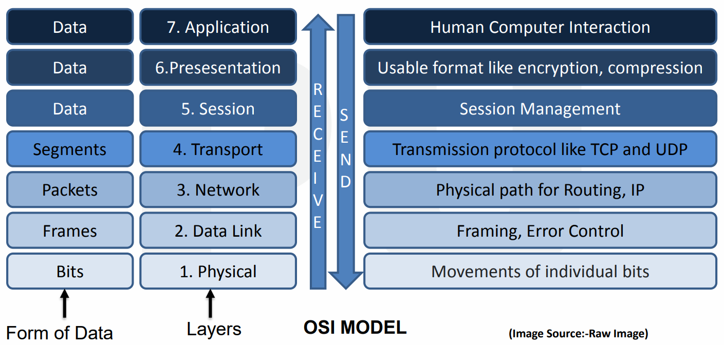

**Physical Layer**

* Movement of **bits** from one hop (device) to the next.
* **Hop:** Node
* **Frame:** Sequence of bits.
* Physical layer converts **frames** into **signals**.

**Data Link Layer**

* Does **physical addressing** & **framing** (packeting).
* **Physical addressing:** Assigns **MAC addresses** to data packets (both sender & receiver).
* **Framing:** Dividing data into frames.
* Physical link is possible due to presence of NICs.

**Network Layer**

* Sends & receives data segments through **logical addressing**.
* **Logical address:** Assigns IP addresses to data packets (both sender & receiver).

**Transport Layer**

* Ensures that data packets are sent & received properly.
* Uses transmission **protocols**.
* Again **error is controlled** here.

**Session Layer**

* Ensures **security** via **authorization & authentication**.
* **Firewall** works at this level.

**Presentation Layer**

* It does 3 things: **Translation**, **encryption** & **compression** of data.

**Application Layer**

* Protocols are defined at this layer.

**Transmission Media**

* Media is plural of medium.
* It is of two types: **Guided** & **unguided** transmission medium.
* Uses **EM signals** to send data.
* Carries **bit** information in through **LAN**.
* In **copper-based** network, bits are **electrical signals**.
* In **fiber-based** network, bits are **light pulses**.

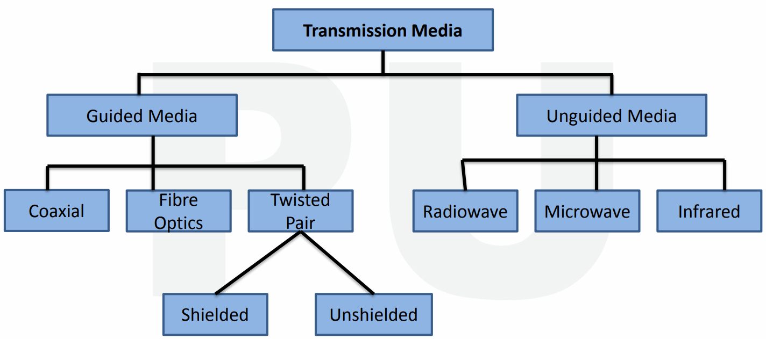

**Causes of Transmission Impairment**

* **Attenuation:** Continuous **loss of energy** when signal is travelling.
* **Distortion:** Signals going in **different** directions.
* **Noise:** Unwanted noise is produced when data is transmitted.

**Twisted Pair Cable**

* Cheap
* Easy to mount.
* Lightweight
* Frequency range = **[0, 3.5KHz]**

Unshielded twisted pair:-

* **Category 1:** Used in telephone lines (low-speed).
* **Category 2:** Upto 4Mbps
* **Category 3:** Upto 16Mbps
* **Category 4:** Upto 20Mbps (long range)
* **Category 5:** Upto 200Mbps
* **Advantages:** High speed LAN, ***\*same as twisted pair\****
* **Disadvantages:** Used for **short** distances, attenuation etc.

Shielded twisted pair:-

* In this, mesh covers wires allowing high rate of transmission.
* **Advantages:** Easy installation, higher transmission rate etc.
* **Disadvantages:** Expensive, higher attenuation etc.

**Coaxial Cable**

* Used in **television chord**.
* Frequency is higher than twisted cable.

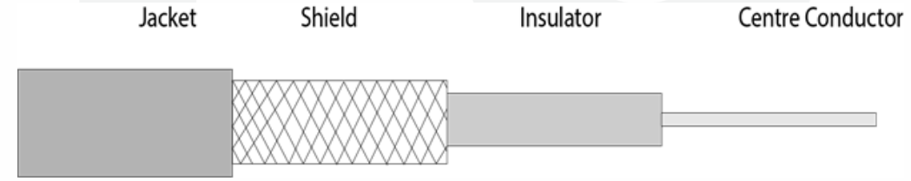

* Middle core **transmits data** & shield prevents **EM interference**.

**Fiber Optic**

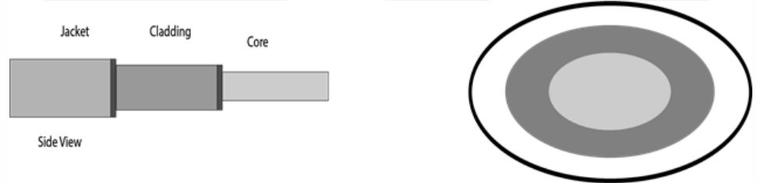

* Core transmits data via **electrical signals** & cladding via **light pulses**.
* The plastic jacket prevents extreme **temperatures** & **EM** interference.
* It is faster than copper wires.

**Unguided Transmission Medium**

* Data are transmitted in form of **EM waves**.
* **It can travel in 3 ways:**
  + Ground propagation
  + Sky propagation
  + **Line-of-sight propagation:** Sender to receiver direct path.

**Radio Waves**

* Emitted to free space in all directions (omni-directional).
* Frequency range = [1kHz, 3kHz]
* Receiving & sending antenna need **not** to be aligned.
* **Example:** FM radio

**Microwaves**

* Antennas must be aligned precisely.
* Works on **line-of-sight**.
* Unidirectional
* Curvature of earth might be a barrier sometimes to it.

**Infrared**

* Frequency range = **[300GHz, 400THz]**
* Infrared also works on **line-of-sight**.
* **Can’t** penetrate walls & is affected by sunlight.
* Thus used in short range communications.

**Types of Computer Networks**

* Types of CN: **PAN, LAN, MAN & WAN**
* Types of LAN: **Wired & wireless**.

Types of wireless LAN:-

* **Peer-to-peer (ad-hoc) mode:** Devices can communicate with each other.
* **Infrastructure mode:** Devices communicate through a central node.

Virtual LAN (VLAN):-

* In this, devices that are part of **separate** wired LAN networks can be connected **together**.
* Network configuration is done through software called **VLAN controller**.

MAN:-

* **Average** transmission speed
* Also used to set up interconnection among multiple LANs.

WAN:-

* Speed is lower than MAN.
* Sets interconnection among multiple LANs or MANs.
* It can even set **hybrid** interconnections of LAN & WAN.

**Differences Between Various CNs**

* ***\*Definition\****
* ***\*Ownership\****
* ***\*Speed\****
* ***\*Delay\****
* ***\*Congestion\****
* ***\*Fault tolerance\****
* ***\*Maintenance\****

**Bandwidth Utilization Techniques**

* **Bandwidth:** Capacity to **transfer data** in bits per second (**Bps**).

Techniques:-

* Multiplexing
* Without multiplexing

**Multiplexing**

* Coaxial cables & optical fibres send one signal at a time, resulting in **wastage** of bandwidth.
* Multiplexing solves this issue by sending **multiple signals** at a time.
* Or rather multiple signals into one.
* Signals come from multiple sources & travel through **one channel** as one signal.
* Then they dissemble (**demux**) to reach multiple destinations at last.
* Multiplexing is also known as **muxing**.

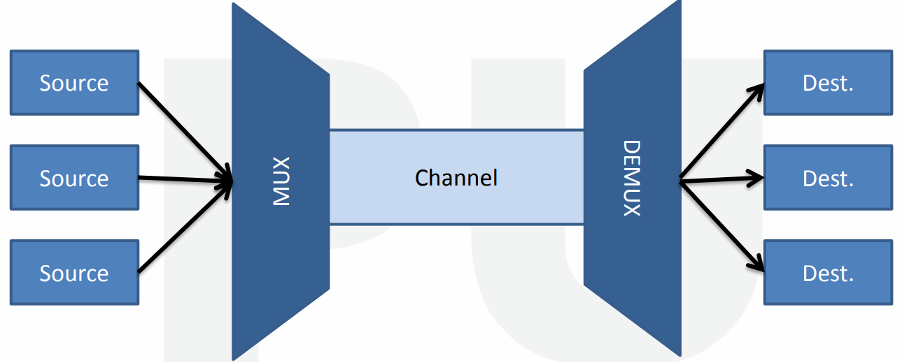

Types of multiplexing:-

* Frequency division multiplexing
* Wavelength division multiplexing
* Time division multiplexing

**Frequency Division Multiplexing (FDM)**

* **Receivers** **multiplex** frequencies & **transmitters demultiplex** frequencies.
* Frequencies are **combined**, then **separated** using muxing & demuxing devices.
* It uses **electrical signals**.
* **Advantages:** No **sync** required b/w transmitter & receiver.
* **Synchronization:** Devices working at same speed.
* **Disadvantages:** Large bandwidth channel is required.

Applications of FDM:-

* FM & AM radio.
* First generation cellular telephones.
* Television broadcasting.

**Wavelength Division Multiplexing (WDM)**

* Similar to FDM.
* It is however an **analog technique** & uses optical signals.
* It is the **most** **effective** & popular technique used.
* Optical signals of different wavelengths & colours are combined & separated.
* **Advantages:** Simultaneous bidirectional transmission, low cost, reduced signal loss.

**Time Division Multiplexing (TDM)**

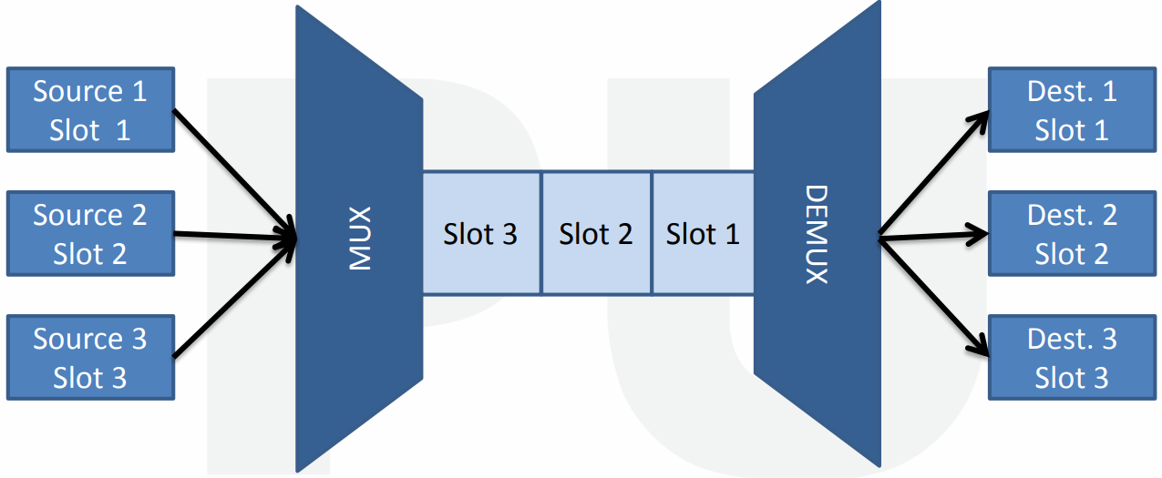

* Signals for different destinations are sent **one-by-one**.
* Different time slots are allocated to users at different destinations.
* The time interval is so less however that no user notices the delay.

**Spread Spectrum Technology (SST)**

Problems with wireless system:-

* **Interference** (when one signal is transmitted near another)
* **Interception** (someone can access confidential information)

Solution:-

* **Broadening** the narrow band signal.
* **Spreading** signal’s frequency.

Types of SST:-

* Frequency hoping spread spectrum (FHSS)
* Direct sequence spread spectrum (DSSS)